PROJECT SETUP

-Open Eclipse -> new java project.
-Delete src folder of new project, and than copy paste the contents of MJCompiler folder into that new project.
Build.xml file won’t be set up properly, so follow up this link:
https://stackoverflow.com/questions/75336081/running-ant-tasks-in-eclipse-with-java-1-8-lead-to-jre-version-less-than-11-is
Command line arguments for MJParserTest.java file are setup this way: 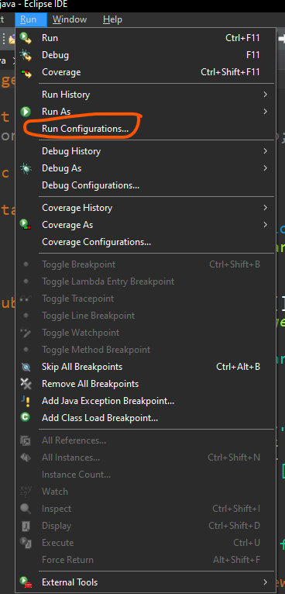
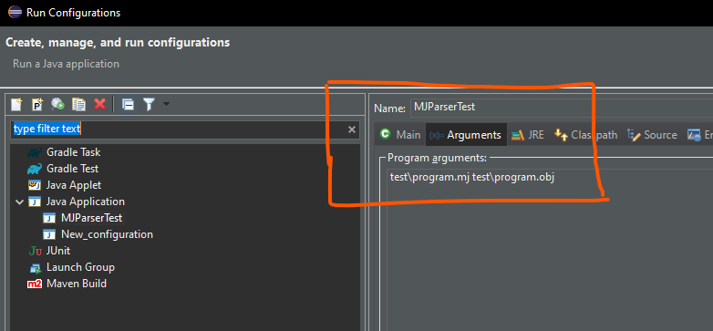

1. If you change lexer or parser, than first go to build.xml -> right click -> Run as ->2 ant build->compile-> and than refresh the Project (you can use F5 for refresh).
2. Start the main program. Right click on MJParserTest.java -> Run as: Java Application. (We run this one only if program.mj file was changed previously).
3. In the end, go again to build.xml -> Run as -> 2 ant build -> runObj.
If parser or lexer were not changed, than only steps 2 and 3 need to be executed.
-Comment/Uncomment on Eclipse: CTRL + SHIFT + C.
-If by any chance eclipse does not show recommendations while typing, set it up this way:
window-preferences-editor-advanced-setting_up_proposals-old
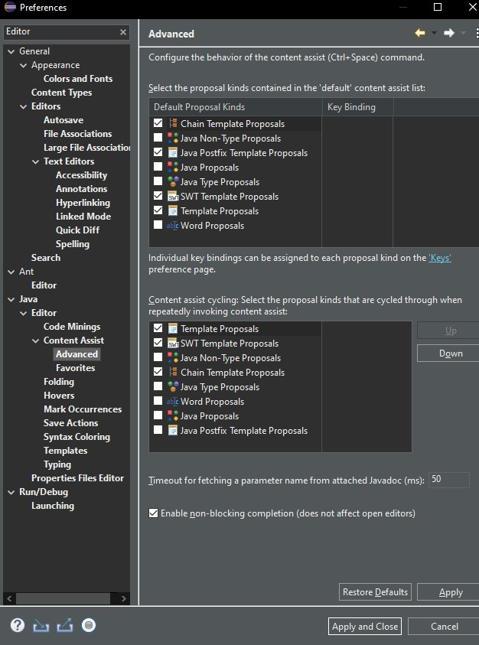
After change:
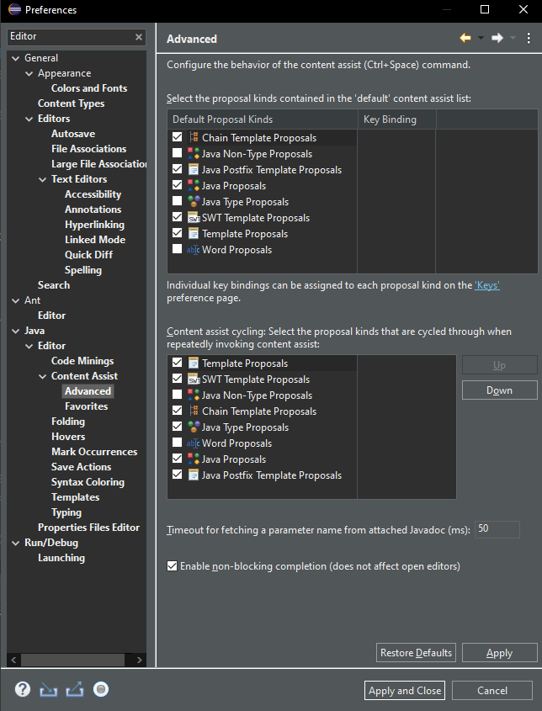

ADVICE FOR MODIFICATIONS
Swap modification done with inline function:
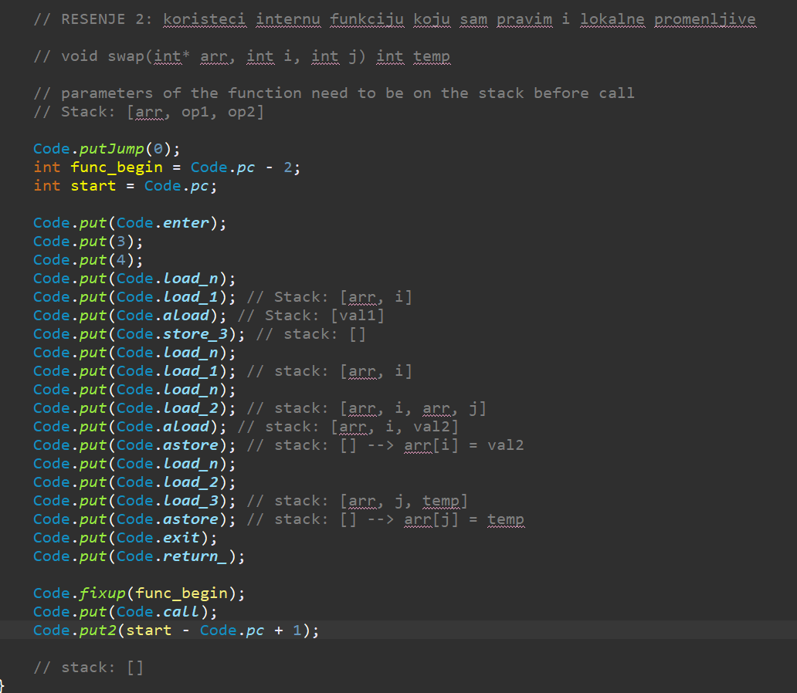
After call always put: put2(adress – Code.pc + 1)

Example of how to copy from dissasembly for CAP modification:
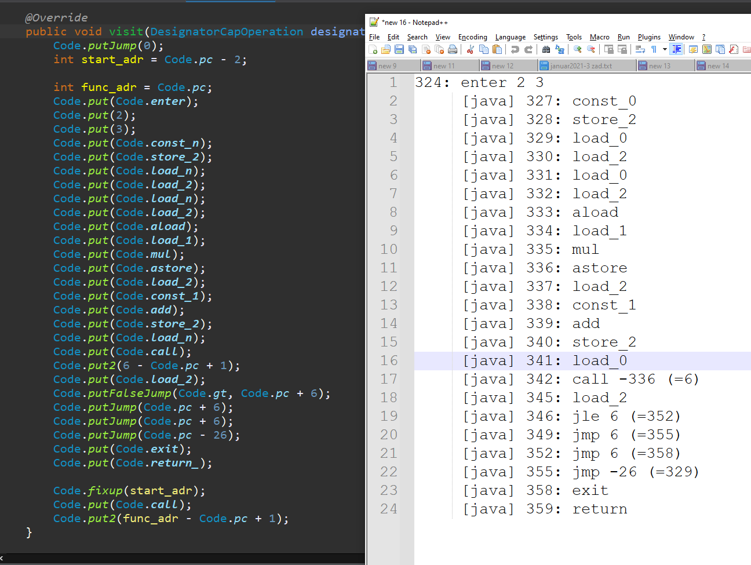
As you can see, for call instruction we take the number in the parenthasis and type:
Code.put(Code.call)
Code.put2(6 – Code.pc + 1);
For jumps, if for example it is jle, we use putFalseJump with opposite, which would be gt.
We use the number near instruction (not from parenthasis) and add it to curret pc.
Jle 6 (=352) Code.putFalseJump(Code.gt, Code.pc + 6)
For non conditional jumps (jmp) we do the same, just without condition.
Jmp 6 (=355) -> Code.putJump(Code.pc + 6)

Also reminder that Code.put writes in Code memory, and Code.load puts the object on the expression Stack. Those two are 2 different memories.

